Jeremy Chan

Professor Matt Lang

Econ108

May 31, 2022

Do ratings affect Video Game Sales?

For my regression project I chose to jump into the field of video games since it has been a hobby that has been in my life for quite some time now. My question is, do video game ratings affect the sales the game will obtain? In order to understand this question, I believe it is vital to understand the type of ratings a video game can receive and what they mean. For the purpose of the data that I used, I will only focus on the ratings E, M, T, and E10+. For starters, ratings generally serve as a summary for buyers that provide a general idea of what they are expected to encounter when playing the video game. For example, a rated E (Everyone) game has content that is generally suitable for all ages. A rated E10+ (Everyone 10+) game has content that is generally suitable for ages 10 and up. These games may include mild violence. A rated T (teen) is content that is generally suitable for ages 13 and up, these games may include content that has minimal blood, simulated gambling, and infrequent use of strong language. Lastly a rated M (mature) game is content that is generally suitable for ages 17+ which may include content that portrays intense violence, blood and gore, and strong language. Now that we have an understanding of how video game ratings work, I predict that video game ratings do affect the sales of the game. First, I believe this because video game ratings give a general idea of what audience the game calls to. For instance, a video game rated Everyone would by far have a stronger player base because it includes content that anyone can enjoy. Toddlers, teenager, adults even can enjoy these types of games. While a rated Mature game may only have adults and older people playing it assuming that the general public follows these ratings. In short

For my data I found my data off of Kaggle, which is an online community of data scientists that create and post data. I found a chart that incorporates the type of video game, its title, rating, and platform. The chart then includes the number of sales the game projected within North America, Japan, Europe, and globally. For my question I focused primarily on the sales related to the video games rating. The type of regressions I ran were linear regressions.

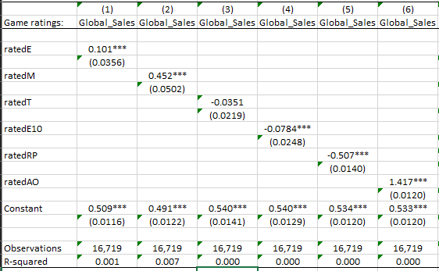

Initially I did run regressions for all three regions, which again were Japan, North America, and Europe. The results were pretty consistent other than Japan having negative coefficients for all video game ratings. I did further research and came to the conclusion that this can be the result of Japan’s regressions having limitations. Meaning the video game cultural is vastly different in Japan compared to North America and Europe. In hindsight in order to simplify the tables to help account for the biases in the Japanese market, I ran regressions on the global sales of the video games compared to doing it by region.

The β1 for rated E video games was equal to 0.101, meaning when the amount of rated E video games increases by one, the global sales of video games increase by 0.101 on average holding all things constant. The β1 for rated M games was equal to 0.452, meaning when the amount of rated M video games increases by one, global sales of video games increase by 0.452 on average. The β1 for rated T games is equal to -0.0351, meaning when the amount of rated T games increases by one, global sales of video games decrease by 0.0351. The β1 for rated E10 games is equal to -0.0784, meaning if the amount of rated E10 video games increases by one, global sales of video games decrease by 0.0784 on average. The β1 for rated RP games is equal to -0.507, meaning if the amount of rated RP games increases by one, global sales of video games decrease by 0.507. Lastly, I ran a regression on video game ratings that received a Rated Pending rating. However, I believe it is unnecessary to include this one because within the dataset I realized there was only about 2-3 games that were rated RP.

After running these regressions and further analyzing I believe video game ratings do affect the sales of the games. We can see this is evident with the coefficients we obtained when running multiple regressions. The rated Everyone and rated Mature video games had the highest coefficients. What surprised me was that Mature video games was higher compared to Everyone rated games. I thought it would have been the opposite since more people can enjoy Everyone rated games such as kids ranging to elders. After research, this does make sense when you consider some of the highest grossing rated M franchises such as Halo, Grand theft auto, Call of Duty, Mortal Kombat, and most recently Fromsoftware’s Elden Ring. Some of the limitations I can think of for these regressions would be not accounting for any omitted variables that may be affecting our regressions. Earlier, I compared and contrasted the Japanese video game market having pure negative coefficients opposed to the European and north American market. I came to the conclusion that this was due to the video game culture being vastly different in Japan compared to its counterparts. These findings may have skewed the coefficients since the global sales incorporates all three markets.